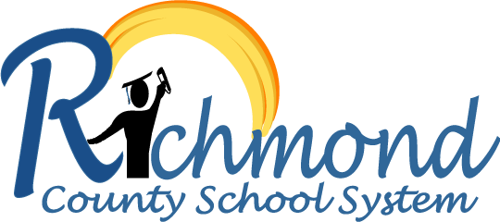

RCK 12 Science

Middle and High School Instructional Expectations Manual

***Table of Contents***

**RCSS Mission, Vision, and Belief Statement** 2

**Science Department Mission, Vision and Core Beliefs** 3

**RCK 12 Instructional Framework** 4

**Tier 1 Instructional Expectation** 5

RCK12 Science in 3D 6

RCK12 Science in 3D “Look-Fors” 7

Is it a Good Phenomenon? Can it anchor 3D Learning? 8

Science and Engineering Practices 9

Science in 3D Instruction 11

**Instructional Toolbox to Support Science Instruction** 12

### **RCSS Mission, Vision, and Belief Statement**

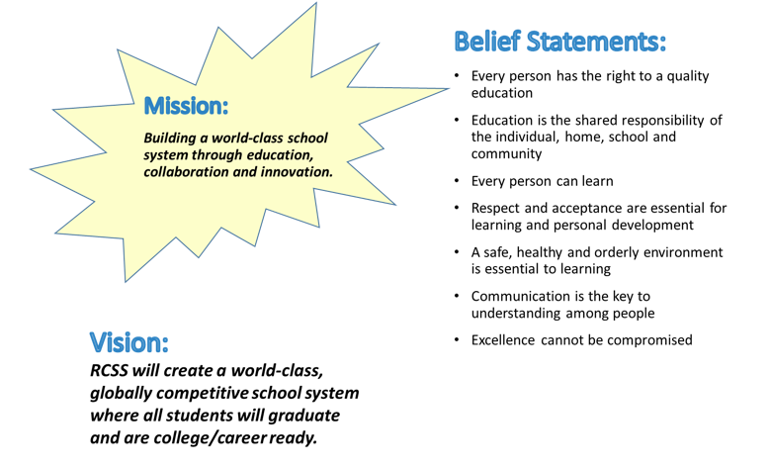

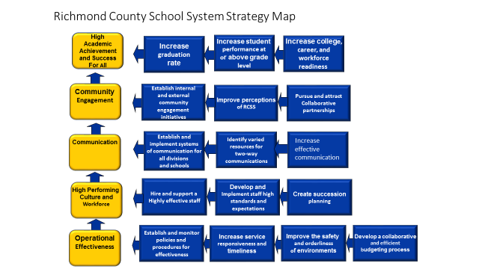

### **Science Department Mission, Vision and Core Beliefs**

**VISION:** **All** Richmond County students will experience high quality science and engineering instruction that will build their capacity to become scientifically literate and environmental stewards of their community.

**MISSION STATEMENT:** The Science Curriculum Department is committed to engaging the students of Richmond County in a relevant, rigorous and comprehensive RCK12 Curriculum that develops a strong knowledge of science content as well as strengthen problem-solving and critical thinking skills.

**CORE BELIEFS:**

***We believe a scientifically literate student will be able to work individually and cooperatively through the use and application of technology to:***

* ask questions (for science) and define problems (for engineering).
* construct explanations (science) and design solutions (engineering).
* develop and use models to make decisions about real world problems:
* plan and carry out investigations using critical and creative thinking.
* draw conclusions by analyzing and interpreting data.
* use mathematics and computational thinking.
* obtain, evaluate, and communicate information.
  + Acknowledge the limitation of scientific information and the continuing evolution of scientific knowledge.
* engage in scientific argumentation.

### **RCK 12 Instructional Framework**

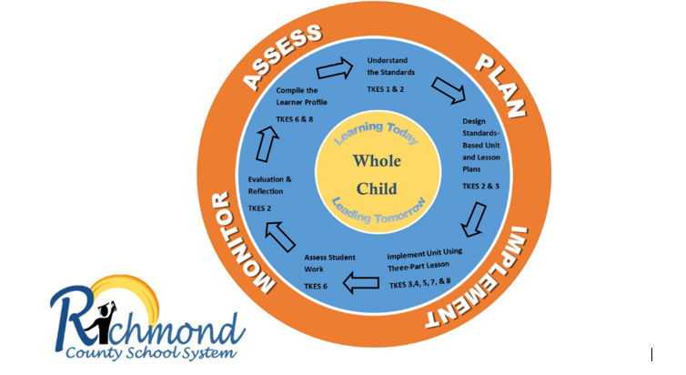

**PLAN**

**Compile Learner/Class Profiles (TKES Standards 6 and 8)**

Set Learning Goals for each Student

Adjust/Differentiate Instruction based on Quantile Data from iReady

**Understand the Standards (TKES Standard 1 and 2)**

Review Learning Targets and Success Criteria for each Unit

Identify Key Vocabulary

**Design Standards-Based Units and Lessons (TKES Standards 2 and 3)**

Review District Developed Standards-Based Units

Review and/or Develop Pre and Post Assessments for the Unit based on the Learning Targets

**IMPLEMENT**

**Implement Unit (TKES Standards 3, 4, 5, 7, 8)**

Teach Three-Part Lesson that includes the 5Es and Formative Assessment

Provide interventions for Struggling Students

Enrich Students Who Have Met Standards

**Assess Student Work (TKES Standard 6)**

Analyze Student Work to Identify Strengths and Gaps

Provide Feedback

**MONITOR AND ASSESS**

**Evaluation and Reflection (TKES Standard 6 and 2)**

Revisit Student Goals and Make Adjustments According to Student Assessment Data

Identify Interventions for Struggling Students

Identify Students Who Have Met Standards and Need Enrichment

## **Tier 1**

## **Instructional Expectation**

### **RCK12 Science in 3D**

(Phenomenon Based Instruction)

The Richmond County School System provides a Standards-Based Science program aligned to the Georgia Standards of Excellence (GSE). The Georgia Standards of Excellence (GSE) are designed to provide students with the knowledge and skills for proficiency in science that will support students to become College & Career Ready and to become scientific literate. 3-Dimensional Learning can promote literacy when the teacher creates literacy- rich projects that require active reading; making inferences, analyzing data, drawing conclusions and justifying results in writing and using scientific texts as the anchor for rich discussions and debates. 3-Dimensional Science instruction will be comprised of the following three components:

1. **Core Ideas:** Provides the key tool for understanding or investigating complex ideas and solving problems, relate to societal or personal concerns, and can be taught over multiple grade levels at progressive levels of depth and complexity.
2. **Science and Engineering Practices:** Describes behaviors that scientists and engineers engage in as they investigate the world and design solutions, and students engage in these same practices.
3. **Crosscutting Concepts:** Help students connect ideas across domains of science *(life, physical, earth and space and engineering design)* and provide them with tools to make sense of new observations and information.

**Reference**: Northeast Georgia RESA-Science, 2016 and Teaching Channel

### **RCK12 Science in 3D “Look-Fors”**

**CLASSROOM** **ENVIRONMENT/ROUTINES**:

* Essential Questions and/or Learning Targets related to Georgia Standards of Excellence (GSE) or key science concepts are posted and referred throughout the lesson.
* Routines are clearly defined, communicated and followed.
* Science safety is clearly defined, communicated and followed.

**TEACHER’S DAILY INSTRUCTION**:

*Teacher(s) Should:*

* Align all instructional activities based on the Georgia Standards of Excellence (GSE).
* Follow the RCK12 Curriculum Pacing Guide which serves as a guide to what students will be learning in the classroom at any point throughout the year.
* Use evidence of learning through 3-Dimensional Learning with the incorporation of the 5Es Instructional Model.
* Use Essential Questions and/or Learning Targets to help students understand the purpose and focus of the lesson.
* Integrate real-life applications to exemplify how the disciplines co-exist in actual practices
* Deliver standards-based curriculum using appropriate pedagogy/instructional materials/instructional strategies.
* Introduce scientific vocabulary after students have had an opportunity to explore a scientific concept.
* Move around the room, guiding cooperative learning groups in formulating solutions and using manipulatives.
* Use formative and summative assessments that focus on problem-solving and deep understanding, rather than memorizing facts.

**STUDENT BEHAVIOR:**

*Students Should:*

* Actively engage and work cooperatively in small groups to complete investigations, test solutions to problems, and draw conclusions. Use rational and logical thought processes and effective communication skills(writing, speaking and listening)
* Ask questions, define problems, and predict solutions/results
* Design, plan and carry our investigations to collect and organize data (i.e. science notebook/journal).
* Develop and use models.
* Obtain, evaluate, and communicate information by constructing explanations and designing solutions
* Analyze and interpret data to draw conclusions and apply understandings to new and novel situations
* Acquire and apply scientific vocabulary after exploring scientific concept.

### **Is it a Good Phenomenon? Can it anchor 3D Learning?**

Making sense of and being able to explain phenomena are central to 3-dimensional learning. It is very important for teachers to be able to identify educationally productive phenomena. A **phenomenon** is defined as an observable event, demonstration or process that generates questions from students. A phenomenon might be condensation on the outside of a glass, a wonderment (how the Grand Canyon formed?), a discrepant event (clingy socks?), or an engineering problem (how can we design a chemical system to produce maximum product?)

So, how can you tell a good phenomenon from an unproductive phenomenon? When identifying a good phenomenon, teachers should select a phenomenon that can meet as many of the following criteria. Teachers need to be mindful that few phenomenon will meet all criteria.

Criteria in white are vital and teachers should avoid phenomena that do not fulfill those particular requirements.

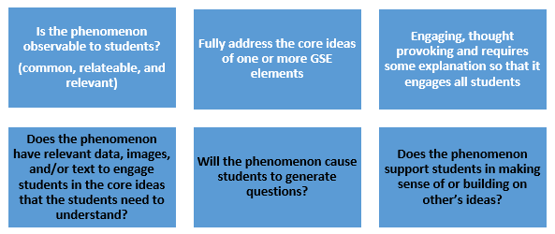

***Remember: Phenomenon do not have to be Phenomenal ☺***

**Reference:** GSTA, 2017

[www.georgiascienceteacher.org](http://www.georgiascienceteacher.org)

### **Science and Engineering Practices**

The Science and Engineering Practices describe behaviors that scientists and engineers engage in as they investigate the world and design solutions, and students should engage in these same practices. The science practices are not independent, but rather they overlap and work synergistically in classrooms.

|  |  |
| --- | --- |
| #1 Asking Questions  What it Means:   * Scientific questions lead to explanations of how the natural world works and can be empirically tested using evidence.   How the Students Own It:   * Scientific questions lead to explanations of how the natural world works and can be empirically tested using evidence. * Ask questions that can be answered using evidence from investigations or gathered by others. | #2 Developing and Using Models  What it Means:   * A model is an abstract representation of phenomena that is a tool used to predict or explain the world. Models can be represented as diagrams, 3-D objects, mathematical representations, analogies or computer simulations.   How the Students Own It:   * Create or use models to explain and/or predict scientific phenomena, processes, or relationships. * Evaluate the merits and limitations of models. |
| #3 Planning and Carrying Out Investigations  What it Means:   * An investigation is a systematic way to gather data about the natural world either in the field or in a laboratory setting.   How the Students Own It:   * ​Design investigations that will produce data that can be used to answer scientific questions. This includes determining the goal of the investigation, developing predictions, and designing procedures. | #4 Analyzing and Interpreting Data  What it Means:   * Analyzing and interpreting data includes making sense of the data produced during investigations. Because patterns are not always obvious, this includes using a range of tools such as tables, graphs and other visualization techniques.   How the Students Own It:   * ​Analyze and interpret data to determine patterns and relationships. * Represent data in tables and graphs to reveal patterns and relationships. * Consider the limitations of data analysis such as sources of error. |
| #5 Using mathematical and computational thinking  What it Means:   * Mathematical and computational thinking involves using tools and mathematical concepts to address a scientific question.   How the Students Own It:   * ​Describe, measure, compare, and estimate quantities (e.g., weight, volume) to answer a scientific question. * Organize data in graphs or charts * Use mathematical concepts (e.g., ratios) to answer scientific questions. * Use digital tools to accomplish these goals when appropriate. | #6 Construction Explanations  What it Means:   * A scientific explanation is an explanatory account that articulates how or why a natural phenomenon occurs that is supported by evidence and scientific ideas.   How the Students Own It:   * ​Construct an explanation for a natural phenomenon. * Use evidence (e.g. measurements, observations) to construct or support an explanation. * Consider the qualitative or quantitative relationships between variables to explain a phenomenon. * Apply scientific ideas to construct or revise an explanation |
| #7 **Engaging in argument from evidence**  **What it Means:**   * Scientific argumentation is a process that occurs when there are multiple ideas or claims (e.g. explanations, models) to discuss and reconcile. An argument includes a claim supported by evidence and reasoning as well as evaluates and critiques competing claims.   How the Students Own It:   * ​Construct and refine arguments based on evidence and reasoning (understanding of disciplinary core ideas). * Compare and critique two arguments based on the quality of their evidence and reasoning. | #8 **Obtaining, evaluating, and communicating information**  **What it Means**   * Obtaining, evaluating and communicating information occurs through reading and writing texts as well as communicating orally. Scientific information needs to be critically evaluated and persuasively communicated as it supports the engagement in the other science practices.   How the Students Own It:   * Read appropriate texts and related features (i.e. graphs) to obtain scientific information. * Evaluate the information gathered from texts and other sources. |

Reference: Instructional Leadership for Science Practices (ILSP), 2016

<http://www.sciencepracticesleadership.com/>

### **Science in 3D Instruction**

**5E Instructional Model**

|  |  |  |
| --- | --- | --- |
| **Opening**  ***(Engage)*** | **Work Period**  ***(Explore, Explain, Extend)*** | **Closing**  ***(Evaluate)*** |
| Whole group  Create a need to know/create an interest  Assess prior knowledge  Focus on a problem/ask questions  Ask questions about the real world  Note unexpected phenomena(natural occurrence) | Small Group or Independent  Design & conduct experiments  Clarify understanding    Define concepts or terms  Build on their understanding of concepts  Use knowledge of concepts to investigate further-extension  Apply explanations and skills to new, but similar, situations | Whole group or Independent  Portfolios  Performance assessments    Demonstrate and understanding or knowledge of concept or skill |

### **Instructional Toolbox to Support Science Instruction**



**Creating a Positive Learning Environment:**

Believe All Students Can Learn

Think Scientifically

Develop Positive Attitudes and Motivation

Reinforce Progress and Effort

Teach Students to Be Metacognitive

**Identifying Important Content:**

Engaging Students with Content

Identifying Preconceptions and Prior Knowledge

Assessment-How Do You Know That They Learned

Sequencing the Learning Targets into a Progression

**Developing Student Understanding:**

Engaging Students in Science Inquiry

Implementing Formative Assessments

Addressing Preconceptions and Prior Knowledge

Providing Wrap-Up and Sense-making Opportunities

Planning for Collaboration Science Discourse

Providing Opportunities for Practice, Review and Revision